Public Inquiry 10th May 2005: Georgeham Parish - Byway Open to All Traffic Number 48 & 49
Mill Lane/Cloutman’s Lane/Milkaway Lane

Statement of evidence in support of the case that the Orders be not made.
Michael John Harrison, Rose Cottage, St Mary's Road, Croyde. EX33 1PF

1. Introduction
1.1 I live in St Mary's Road and my family have used these paths over several generations. I will put the case that the county council’s proof of evidence is deficient of evidence, contains conjecture and unsubstantiated assertions. In consequence, the Orders should be not made.

2. Historical evidence of use: Map evidence.
2.1 There can be no dispute about the ancient nature of the tracks concerned. Their existence is self-evident and species diversity indicates considerable age. However the characteristics of the tracks need to be considered along with other historical and physiographic information.

2.2 The tracks existed to provide access to fields for agricultural use. In the lower part of the valley were many orchards, requiring fencing as they were also grazed. Larger fields grew wheat and higher up there were grazing areas for stock. The lanes served to access animals and bring in the harvest. Hay was brought down to the village and stored in large ricks in the farmyard. Evidence for this pattern can be seen in the Tythe Map, in eye-witness descriptions of the time – 24th August 1885: “There are such quantities of corn still out” – from old photographs and from the size and architecture of threshing barns in the village (still existing – see Annex 1). This use related to villagers who owned or rented the land.

2.3 The question is whether there was a more general use of the lanes by the public and if so what was the nature of the use. The county council’s proof of evidence 9.3 (summary 3.2) suggests that “they have been used and regarded in the same way as other public roads in the vicinity”. No evidence is given and the timing referred to is vague. Prior to the construction of the railway to Braunton and Ilfracombe in 1874, Croyde received very few visitors. The 1871 census records 17 farms and only one lodging house. By 1881 this had increased to three and by 1891 five, by which time larger, purpose built holiday accommodation was available. The function of the minor lanes was overwhelmingly agricultural until at least the 1880s and almost certainly until very much more recently. The lane/road along the bottom of the valley which split at Forda, leading on to Georgeham or Braunton was evidently used as a general transport link connecting Croyde with the outside world. Directness, destination and gradient determined which routes were used generally and which were not.

3. Historical evidence of use: User evidence.
3.1 There is evidence of use by the public of the various lanes in Croyde dating from 1880s. However the nature of this use varied according to which lanes are considered. Capt. Heddon had accommodation at Croyde Bay and ran carriages to bring his clientele from Braunton station (see, for example, North Devon Journal 23rd May 1889). He also offered ‘drives’ around the area to places such as Ilfracombe and Mortehoe. In all these cases the carriages made use of the major roads. Maria French Simon spent the summer of 1885 in Croyde and thoroughly explored the area on foot and by donkey and cart (see Annex 2 & 3). She recorded her activities in letters written to her husband who stayed to work in Bristol. 1st August – “we hired a donkey and cart and went to Woolacombe Sands”. 13th August – “I shall have to pay Capt. Heddon for bringing us here and also for driving us to Braunton next Monday”. 13th August – “We started for a walk us “Hardbake Hill” Grace and Sadie call it up a lovely lane and along a gradual ascent up a hill side”, then on to Saunton Court. 15th August – “our expedition to Mortehoe . I hired Mrs Ley’s donkey and cart and we drove ourselves”. 19th August – donkey cart to Woolacombe Sands. 20th August – “We are starting now for a walk to Saunton Sands”. 21st August – walk to Braunton station (missed train!). 21st August – walk to Braunton station and on return “we had our donkey cart to come and meet us”.

3.2 What these excursions show is that certain routes were considered suitable for wheeled traffic and others were not. In the first category were lanes to Braunton and Georgeham and also Combas Lane. In the second category were Mill Lane, Cloutman’s Lane and Milkaway Lane – excursions on these routes were on foot. The reason is simple: the lanes contain very steep sections.

3.3 Moving on the 1900s, a similar pattern emerges. Maria’s daughter, Elsie recorded each day’s activities in her diary. In this case carriages were used to transport people and luggage from Braunton station to Croyde but otherwise it was a choice between the bicycle or going on foot. In August 1902 she would cycle to Barnstaple for market day, to Braunton to catch the train and she arrived in the area by bicycle from the paddle steamer at Ilfracombe. She mentions walking up “Hardbake Hill” as mentioned above, i.e. Cloutman’s Lane. She saw little point taking a fixed wheel, no gear bike up steep lanes. Later on in the 1920s when motor vehicles appeared the family Austin 8 made regular trips to Braunton and Barnstaple and even to Hunter’s Inn. Going for a drive was fashionable. However on the local lanes the family walked and the hills were judged excessive for vehicles.

3.4 The chief factor why the usage of these lanes was different was their steepness. Mill Lane has a sustained gradient of 29% with steeper sections at 36% to 40%. Cloutman’s Lane at the corner where it joins Mill Lane is 23%, and 28% on the inside of the bend. Until recently only farm vehicles were powerful enough to use these lanes. Last year I put sacks of manure on my bike rack and cycled up Cloutman’s Lane. At the bend, the chain slipped, the front wheel rose in the air and I was flipped backwards – some gradient!

3.5 The county council proof of evidence suggests similarities between proposed routes 48/49 and other roads in the area. Proof of evidence 4.2 “Their use as roads appears to have changed”. Proof of evidence 9.2 (summary statement 6.2) states: “Their use as connected roads has changed from use by all traffic to use mainly by people on foot and horseback”. User evidence that I have from letters and diaries indicate that this was not the case. The use of the lanes in question was clearly different from what now forms the road network. There appears to be no evidence for the county council statements in proof of evidence 4.2 (summary 6.2). Neither is there evidence for statements in Proof of evidence 9.3 (summary 6.3): “appear to have been used and regarded as other public roads in the vicinity”. Proof of evidence 9.7 (summary 6.5) claims “documentary evidence” but no explicit evidence of use is provided.

4. More recent use
4.1 It is clear from the information included that in the last 50 years public use of these lanes has been almost exclusively on foot or horseback. Some vehicles belonging to people owning adjacent property also use the lanes: these residents have such rights. I concur with these findings. In my letter of objection (11th January 2004) I stated that I walked Mill Lane several times a week but never saw a sign of a motor vehicle until the placement of notices in late 2003. It is claimed in Proof of evidence 9.2 (Summary 6.5) that “there is also some public vehicular use”. This is unquantified and is misleading: in reality, up to late 2003 it approached zero.

5 Conclusions on historical evidence and use
5.1 Mill Lane, Cloutman’s Lane and Milkaway Lane were probably used exclusively for agricultural purposes prior to 1880. Since then they have remained predominately concerned with farm use until the last 40 years.

5.2 These lanes historically have been unsuited to wheeled traffic and therefore their use has largely been restricted to movement on foot or horseback. Writings from different dates provide evidence endorsing the relationship between usage and steepness.

5.3 More recent evidence makes clear that public use of these lanes has been almost exclusively on foot or on horseback. It is only with the proliferation of powerful motor vehicles that their use in such lanes has become feasible. A historical right cannot be claimed on this basis.

5.4 Assertions of historical use made by the county council are insufficiently backed up by evidence.

6. Meeting statutory obligations and the interests of council tax payers
6.1 The incursion of motor vehicles deep into the countryside would be in contravention of the county council’s Rights of Way Improvement Plan and would be damaging to the local economy. The council has a duty to enhance where possible the ecology and amenities available for residents and visitors. These points I expanded in detail in my letter of objection of 11th January 2004.

6.2 For Combas Lane other circumstances apply. This was the main route between Putsborough and Croyde. Putsborough Manor owned property and land in Croyde and Stentaway Lane was a later arrival. The lane was used by wheeled vehicles in the 19th Century but since early in the 20th Century its use has predominately been one by foot or by horseback. As an alternative route exists, bridleway status would seem appropriate. As such the lane represents an important asset to the local economy.

10th May 2005
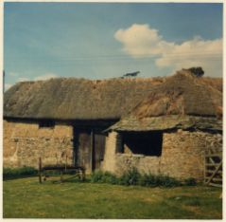 17th Century Threshing Barn, St Mary's Road 1964

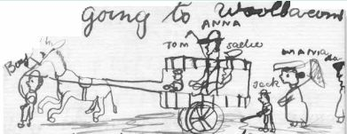11year old Sadie’s picture 1885

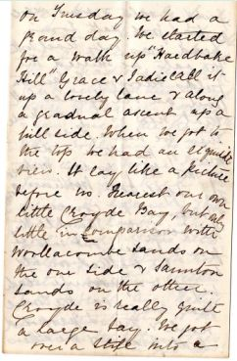Maria French Simon letter 13th August 1885
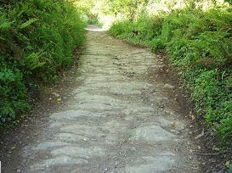Steep and rocky Mill Lane 2005

