Barnstaple by-pass: pedestrian and cycle facilities
A series of correspondence including detailed letters from me and some dumb answers, in particular about getting from the town centre to the college.
- These were set off when I went to the by-pass exhibition and asked “How would I get my bike to college when the by-pass was built?” and was given the answer “Use the new cyclepath and then you could go up the steps”. (half way up Sticklepath Hill).
- Cyclepath widths (1.2m) that would make it difficult for two bikes to pass each other.
- A deviation of the path that was 50m (I had claimed it would add over 100m) without realising that it would be necessary to get back to the original route.
- Path would have to cross busway- if the college is one side and town the other the bus route has to be crossed whatever!

- Letter/email one: February 2005
To Devon CC, copied to MP, Councillors, North Devon College, GOSW, CTC, Sustrans

Local Transport Plan 2006 - 2011 and Reality?

Tackling congestion, improving accessibility, safer roads, better air quality? Improved pedestrian and cycle facilities match all these themes. Perhaps the first large scheme to come along in the funding period arrives with deficiencies in these areas. What value then the rest of the LTP?

Barnstaple Western By pass

The Report of the County Environment Director (03/11/99: ED/99/361/HQ) commented:
“This strategy seeks to give priority to pedestrians, public transport and cyclists whilst redirecting other vehicular traffic away from the town centre.”
“At the bottom of the existing Sticklepath Hill, an underpass will be provided for pedestrians, cyclists and buses. This will provide direct access to the railway station without having to use the new Sticklepath junction. In addition pedestrians and cyclists will be able to access the town centre via the stopped up Sticklepath Terrace.”

With construction now begun concerns are growing that the scheme may not deliver satisfactory facilities for pedestrians and cyclists. There is an opportunity to enhance the pedestrian and cycle network of the town and encourage modal shift. However, if the quality of provision is deficient there could be impairment of the key themes.

Possible shortcomings
1 Design specifications.
The pedestrian and cycle paths associated with the by pass are at or below the minimum widths recommended in the guidelines. I believe that the line segregated paths alongside the bridge and approaches will be 0.5m verge, 1.5m cycle, 1.2m pedestrian (Guideline minima 2.0/1.5 if unbounded; absolute minima 1.5/1.5 or 1.75/1.5 if bounded). In places the verge may contain safety fencing and signs. The intended width for the unsegregated paths would seem to be 3.0m. This is the minimum suggested width and if applied to some of the paths would lead to significant conflict and safety implications between pedestrians and cyclists. Building at or below the minima suggested would seem mean, given the scale of the construction. Three further points apply:
(a) This is an urban area with high demand, for example dog walking or journeys to work or the shops. Facilities should be of ample size.
(b) Sticklepath is the arrival point for many visitors to the area and the Tarka Trail a showcase attraction. Quality and functionality of facilities may influence potential tourist revenue.
(c) Many paths are on significant gradients where the differential speeds will be significant. For reasons of safety it is essential that there is adequate width.
2. Design criteria.
The criteria for cycle and pedestrian facilities are that they are direct, continuous, coherent and safe. The route between the town centre and North Devon College is probably the busiest pedestrian route in North Devon. Local congestion and parking issues make clear the importance of encouraging the sustainable modes. Plans clearly fall short of the criteria. Why should pedestrians and cyclists go on three sides of a square, adding 130m to their journey, so that the station car park can be extended? The alternative route suggested is up steep and narrow steps -–clearly not safe, probably couldn’t cope with flows and is in fact longer. There are additional issues of mixing modes and creating interruptions to the route. This key route provides access to the station and, for people who live south of the river, access to Park School and town centre shops and employment. Elsewhere, it is unfortunate that the deviation of the Tarka Trail is so marked – at least attention could be paid to radii of curves and sight lines.

Clearly observations like these would be more appropriate at the design stage. I am informed that there was a cycle audit on the scheme and that “our engineers are cyclists”. Given the mismatches with criteria, I am surprised. I have been writing, visiting and asking questions for nine months but only now am managing to glean details. There have been and continue to be modifications to the original plans. Ameliorations for pedestrians and cyclists are possible. Yesterday I supplied your person on site, Pete Smith, with information. It would be short sighted and unnecessary to provide less than quality facilities for pedestrians and cyclists.

Mike Harrison Rose Cottage St Mary’s Road Croyde Braunton Devon EX33 1PF
CTC Right to Ride Network Representative for North Devon 25/02/05

- Reply came from D M Cowler, including some doubtful comments about widths (got pedestrian and cycle parts of path the wrong way round) and saying it had been planned and couldn’t be altered.

- Letter two: March 2005
To local councillors, copied to DCC and others.

Barnstaple Bypass – Pedestrians and Cyclists
Dear Councillor

The Barnstaple bypass, construction recently started, will under current plans contain serious shortcomings for pedestrians and cyclists. The three main deficiencies would seem to be:

1. Many of the pedestrian and cycle paths are to be built below current guideline standards.
2. Access to North Devon College has been insufficiently addressed and will create problems.
3. Opportunities to create a more sustainable transport network for the town may be missed.

Three weeks ago I expressed these concerns in an email sent to Devon County Council. The response was prompt but I question the adequacy and accuracy of contents that failed to address these points. I enclose copies of the email and return letter. Below, I explain the background and reasoning in detail for each of these potential problems. Officer speak on this matter is that the scheme is fully planned, got permissions/orders and is under contract. This argument I find unacceptable. There have been flaws in the planning process which should be put right. The plans were modified several times since the original drawings (some parts are still under discussion) and there was and is ample time to amend pedestrian and cycle facilities to meet current standards. The pedestrian and cycle paths are one of the last things to be done and the quality of build does not relate to the traffic regulation orders.

1. Building to Guideline Standards
Information about satisfactory quality of build can be found in ‘Local Transport Notes 2/04: Adjacent and shared use facilities for pedestrians and cyclists’. This came out on 12th May 2004, intended as a replacement for LTN 2/86. Plans for the bypass were mostly produced in 2003 but there have been modifications. Changes could have included much of this information because otherwise the end product would be deemed out of date the moment it opened. DCC claim that they have designed correct facilities according to LTN 2/86. Not only is this nearly twenty years old but also it was superseded by the National Cycle Strategy in 1996, Cycle Friendly Infrastructure IHT 1996, Guidelines for National Cycle Network (e.g. Tarka Trail) in 1997, Guidelines for Cycle Audit and Review IHT 1998 and Guidelines for providing for journeys on foot IHT 2000. Many of the paths planned do not meet these guidelines. A cycle audit should have picked up shortcomings.

It is important to design to current guidelines. Where facilities are substandard, cyclists may well go on and off the carriageway, pedestrians may cross busy highways or private land and there may be collisions or ill feelings between pedestrians and cyclists. In other words safety implications which would reflect on the council. On top of this there would be a failure to mobilise suppressed demand.

DCC in each case appears only to envisage designated minimum standards. There are several reasons why this is not sound. Government guidelines put in bold type: ‘Practitioners should not regard minimum widths as design targets’ (LTN 2/04 6.2.2). Minimum widths are inappropriate on slopes because of the variations in speed. In urban areas there are likely to be higher flows and a large number of people walking dogs. It is also desirable that major tourist facilities have appropriate infrastructure because of potential income generation and for many this is the gateway to North Devon.

The intention is that some of the paths will be segregated and others will be unsegregated. Current thinking is that ‘there should be a presumption in favour of segregation in the absence of reasons for not doing so’ (LTN 2/04 6.1.1). Segregated paths are envisaged for those coinciding with commuter routes whilst unsegregated paths are for those primarily leisure routes (Tarka Trail). This is logical. The problem is with the design of the segregated routes. Figures that I was given by the DCC planner on site were 0.5m verge, 1.5m cycleway and 1.2m footway. The letter from County Hall (8th March/DMCowler) said 0.5m verge, 1.2m cycleway and 1.5m footway with white line segregation. Two bicycles in opposite directions can barely pass each other in 1.2m – the most common handlebar width is 0.6m. These paths are mostly on gradients where speed differences are considerable. There will be use by cycle trailers, child carriers and tricycles which will be problematic given that by law cycles should not cross into the pedestrian part. Clearly these measurements are inadequate and potentially dangerous. LTN 2/04 4.6.2 states “If pedestrian or cyclist usage is likely to be considerable, there should be a presumption towards providing an adjacent cycle track and footpath/footway, preferably segregated by level difference”. The level suggested is 50mm (6.1.10). The minimum acceptable width is 1.5m for a footway (allows pedestrians to pass a wheelchair) (6.2.5) and 2.0m is suggested for cyclists. Section 6.2.6 states: “A cycle track width of 2.0m will allow two cyclists to pass each other but this should be regarded as the minimum acceptable under most circumstances.” It goes on to explain that additional width is required if street furniture is adjacent to the cycle track (table provided in 6.2.10). These dimensions are entirely concurrent with the 1997 guidelines. They are minimum dimensions. The suggestion is that higher figures should be used ‘wherever practicable’.

For a shared use path the desirable minimum width is 3.0m – the width used in the vicinity for much of the Tarka Trail. Such widths should be taken ‘as a starting point’ and ‘local conditions and opinion will need to be taken into account’ (6.2.14). Given that these are predominately leisure routes there would seem to be less of a problem. As above, allowance should be made for adjacent street furniture.

There are other aspects of design that need consideration. ‘In general a design speed of 30-35km/h is desirable for cycle facilities’ (LTN 2/04 9.2.1) and as a consequence sight lines and radii at curves should be adequate. Other issues concern starts/finishes, kerbs, surfaces, signing and maintenance.

2. Access to North Devon College/Barnstaple’s pedestrian and cycle network
The link between the town centre and North Devon College is probably the busiest sub central pedestrian and cycle flow in North Devon. The college generates enormous problems over a wide area with motor traffic and parking. Sustainable movements are desirable and should be promoted. Yet plans for the bypass would seem to degrade such a possibility by adding extra length and involving impediments to smooth progress. I enclose a sheet with a map (on the left) that shows the proposed changes to the lower part of Sticklepath Hill. The right hand map is a suggested variation (details below).

The direct route from Sticklepath Terrace to Old Sticklepath Hill is to be replaced by a curving segregated path beside the new busway to the station. At the college end of this route the suggestion is to continue up steps located half way up Sticklepath Hill. The alternative is to swing back to reach the lower end of Old Sticklepath Hill. According to the DCC response (8th March/DMCowler) this ‘will result in a diversion of no more than 50 metres which is unavoidable if we are to produce a scheme of this magnitude in this location’. A diversion of 50m results in a longer total journey length as you have to get back on the original route – the distance is certainly around 100m and possibly the 130m (or 140m using the steps) of my sketch map.

The council’s suggestion that the steps would form a route to the college takes some comprehending. When I enquired about a cycle route to the college, I was told I could go up the steps! This route fails all the criteria of both the 1996 and 2004 guidelines. The steps are 1.4m wide and could not possibly cope with the peak flows of pedestrians. They are steep and shady and the 33 steps rise 5m, which would prove difficult for people with even minor disabilities. There would be pedestrians going up and down at the same time, perhaps in a hurry. Almost every cyclist would balk at the prospect of carrying a (laden) bike up the steps and to descend with one would be dangerous. A move in either direction would not be possible if pedestrians were on the steps at the time. And then there are the buses, which currently pick up and drop passengers in Old Sticklepath Hill (planned closure at bottom). I have been informed that the buses will stop in Sticklepath Hill though I’m sure this must be under discussion. As the top part is a main road, is it envisaged that they stop lower down and that their passengers also use the steps? I can sense concerned residents in this area. There has to be a better alternative.

Government guidelines state that ‘an overarching principle that any new measures proposed for pedestrians and cyclists should represent a real improvement over the existing situation, particularly in terms of accessibility’ (LTN 1/04 1.1.5). Earlier guidelines stressed the idea of directness (1996 above). The question is what is practicable. DCC’s ‘unavoidable’ can be questioned. The bypass in this location is on a viaduct so that there is a choice in the position that the pathway/cycle track crosses below it. A more direct route is possible, as is indicated on the right hand ‘modified’ map. The constraint would seem to be the desirability of extending the station car park. People and cyclists often cross car parks (and on the suggested plans would be tempted to do so) and it could easily be divided with an overflow section (on present use it is already more than adequate in size). Was enough thought given to this?

Given the importance of this route it is essential that adequate design specifications are used. Probably this would be the busiest of the adjacent use paths in the bypass plans and should be built at more than the minimum widths, together with a 50mm drop, for reasons and information stated in Section 1. Building to Guideline Standards. Some points are suggested on the Modified Version of the maps provided. Design should reflect the core principles of LTN 1/04 3.2.2 – 3.2.7 which for example stress the need to avoid delays and interruptions to a route.

This is not simply a question of providing a quality route to the college. Other actual and potential flows of pedestrians and cyclists use the area and several components of a network of routes for Barnstaple intersect here. Safe Routes to Schools are a high priority. At present a quality route leads from the Park School across the Taw and to Severn Brethren – this can link with the Sticklepath route to give access to residential areas south of the river. A new route is being developed from Pilton Community College to Pottington which will connect with paths across the new bridge. Pedestrian and cycle movements at the top of Sticklepath Hill need to be considered and facilities should be appropriately designed. Links to the station is another special case. Direct, continuous and safe – I hope so! This is also a key commuter route into the town centre or for shopping or leisure journeys.

3. Opportunities for a sustainable future
Where good quality facilities are built in the right place cyclists will appear and use them. Who could have predicted how successful the Tarka Trail was going to be? With the rising cost of motoring and congestion and frustration many people welcome a choice of travel mode. People can enjoy walking significant distances if there is the right environment. Any plan or major development for Barnstaple should be seeking to enhance these possibilities. One of Barnstaple’s attractions is its extensive pedestrian and cycle network, mostly built to a good standard and including pleasant sections of the national cycle network.

Construction of the bypass produces an opportunity to render this network more comprehensive. Such a situation coupled with workplace and destination facilities could radically influence people’s choice of transport mode. Not only would this offer choice to the residents of the Barnstaple area but it would also be in tune with current government strategies with regard to integrated transport. This would be money well spent and could attract more.

Barnstaple’s Western Bypass is clearly Devon’s biggest transport project. It would be a pity if the outcome fell short for a local community interested in sustainable transport and a healthy, pleasant lifestyle. Using documents from 1986 is short sighted. There has been a resurgence in cycling and walking since then, which local planning should reflect.

Yours sincerely Mike Harrison

- Copy of maps of Lower Sticklepath Hill that were referred to
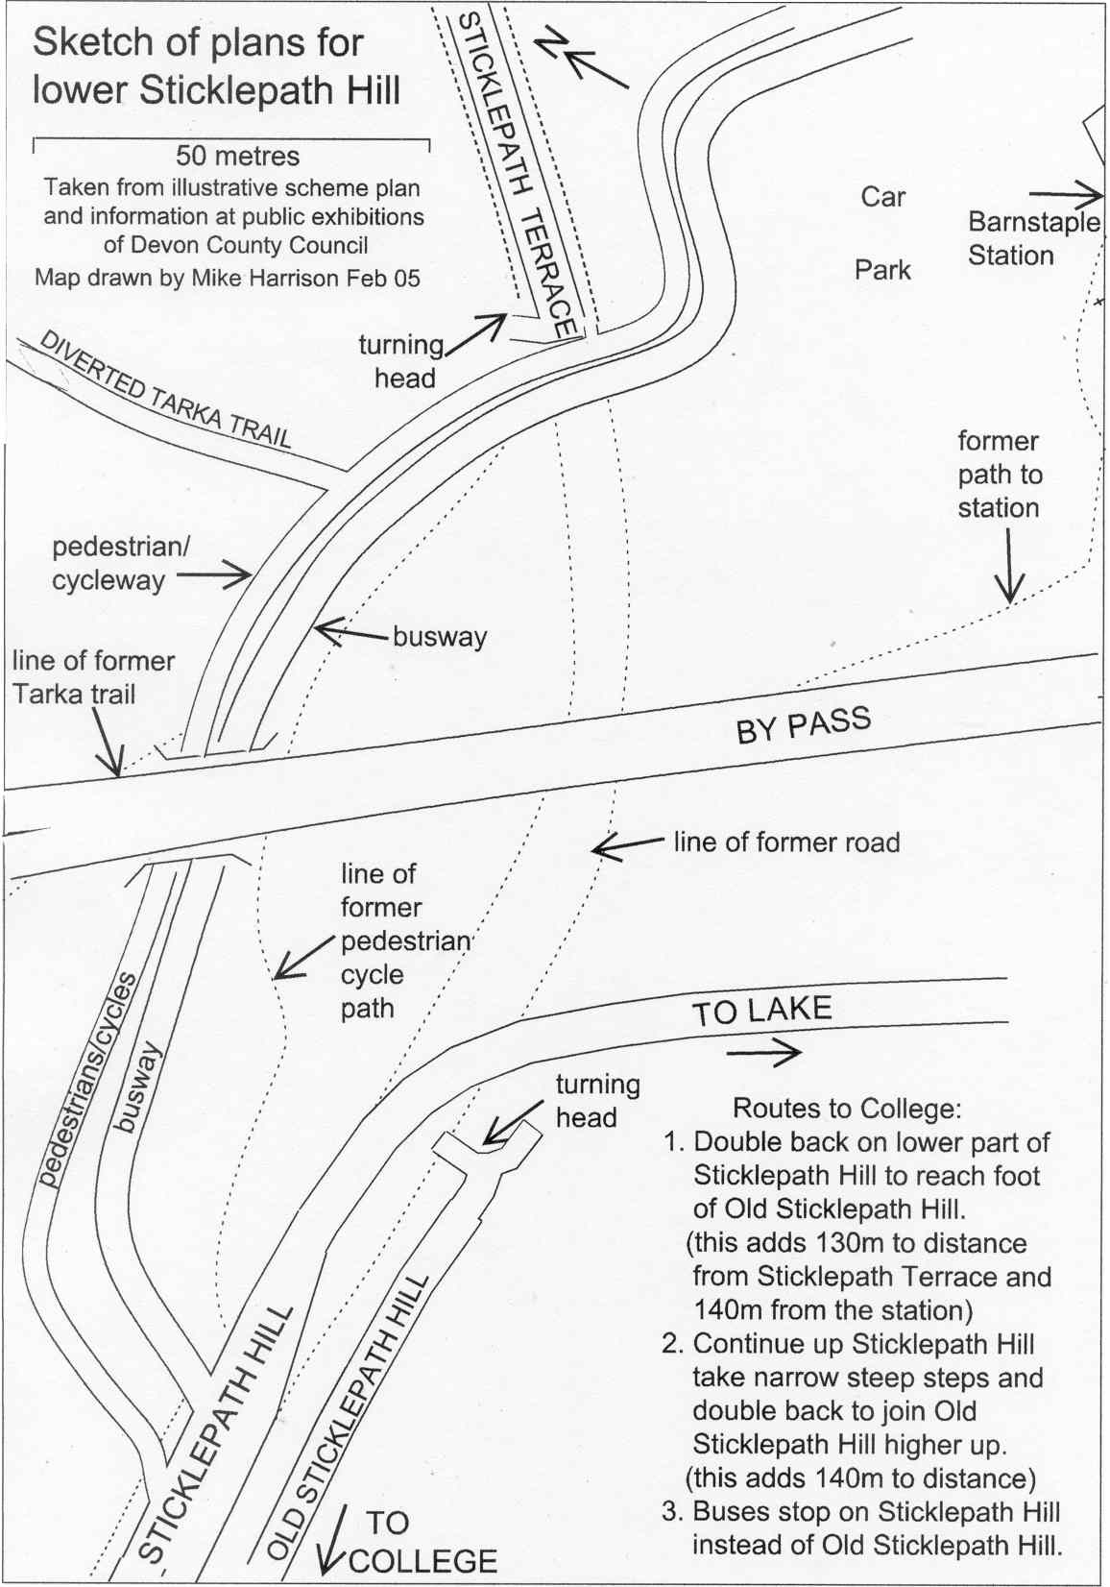
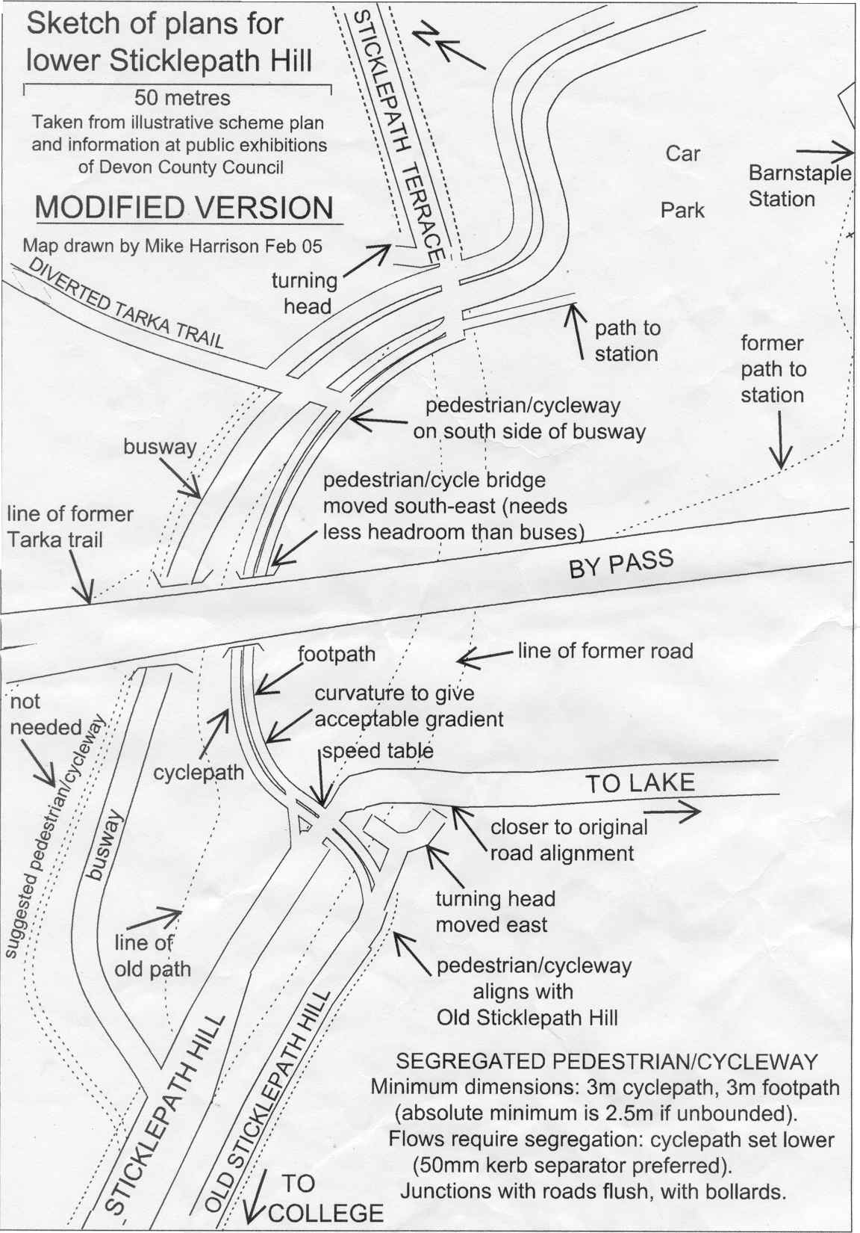

- Reply from Joe Deasy, Local Service Officer A more direct route between the town centre and the college would be unsatisfactory as it would mean having to cross the busway.
- Reply from Ian Harrison, Deputy County Environment Director 18th March 2005
“The scheme was designed using the recommendations in Local Transport Note 2/86.” “The scheme was given planning permission in November 1999. Side Road and Compulsory Purchase Orders published in July 2000 and a Public Inquiry in the summer of 2001.” “It is not possible to apply retrospective changes due to the effect on the landtake already approved in the planning permission and the cycle route layout as confirmed in the Side Roads Order.” The letter also corrected the width of facilities to 0.5m verge, 1.5m cycleway and 1.2m footway. Mr Deasy’s letter deals with access to the college. Also the one “in the scheme is already at a gradient of 1 in 12 and your alternative shorter route would steepen this to an unacceptable degree.”
- Reply from Councillor Brian Greenslade saying he has seen Ian Harrison’s letter and can add no further comment.

- Letter three: to Ian Harrison 23rd April 2005

Dear Mr Harrison

Thank you for your letter of 19th April. I was pleased to receive an informative reply and note your correction of the obvious error. However I made many specific points in my letter for which I still await answers. After some general points, I will comment on specific parts of the scheme in response to the details of your letter. I want to see positive stories in the media with new facilities enticing people to walk or cycle.

My main concern is with safety. Some of the paths are likely to carry considerable flows of pedestrians and cyclists and, particularly as they are on gradients, their narrowness may create unacceptable levels of risk. My second concern relates to inconvenience, the consequence of which may be a decline in use and thus a question of value for money. Without good facilities cyclists will opt to ride on the road. I don’t feel that these issues are being adequately addressed. However it would seem possible that the overall picture could be lost. Where high quality pedestrian and cycle facilities are provided, they attract use. This brings health, economic and environmental benefits to users and can enhance the value of the area as a whole. Moreover, it will ease congestion at by-pass nodes.

Your main justification for building as designed is that it has gone through the inquiry and orders phases and cannot be changed. I do not recollect public inquiries discussing the minutia of pavement widths, these are design details not matters of route or land. Nor do public consultations seem to provide adequate information – it took me consultations, exhibitions, visits and letters before I could determine relevant details. Difficulty of change may also be a myth. Access to North Devon College is still under discussion, as are links with development sites and what happens in the Strand. In the eight or so years since the main plan was drawn up things have changed: global warming, fuel price concerns, congestion, standards of air quality, more choosing to walk or cycle. The public expect proper facilities to be built, that is ones appropriate to the time. I include here Nick Harvey who went even further than I do, when I discussed it with him a few days ago. Devon has been a bench mark for good practice: now it is only to match basic standards on the pretext that it was planned eight years ago to twenty year old guidelines. Not impressive!

Broadly speaking there are three types of pedestrian and cycle path involved. Those that run east-west and are primarily leisure routes related to the Tarka Trail. These are designed as 3.0m unsegregated paths. This is the design minimum and would seem to be adequate, though thought should be given to the design and sight lines at sharper curves. Running north-south are important commuter flows which are likely to carry heavier and faster moving traffic. With these segregated paths I am concerned that the 1.5m/1.2m will not be adequate. I explained details in earlier letters so I merely highlight a few points here.

The route alongside the new bridge has a strategic role for pedestrians and cyclists. Many live south of the river and work to the north with a journey of a few miles. This route can help people to access Pilton School, Pottington, the hospital and the Civic Centre. A direct, continuous and safe route would make a significant contribution to Barnstaple’s traffic flows. It should be built to current design standards, i.e. a minimum of 1.5m pedestrian and 2.0m cycle paths, with 50mm drop as segregation and at least 0.5m separation form carriageway. This is important because of the gradients as it leaves the top of Sticklepath Hill and as it drops down to Pottington. On the bridge itself some reduction from these figures could be acceptable given that on a crest cycle speeds would be lower and also because the bridge is already commissioned. These figures imply an extra 800mm of surface beside the sloping carriageways which would not seem a technical problem and would keep the planned alignment, though it would add expense.

A greater issue relates to the bottom of Sticklepath Hill and access to North Devon College. Here the concerns are that the likely flows and the route itself have not been adequately thought about. As such, I feel there should be amended orders and a substantial upgrade in the provision (as I have detailed before). People will choose to go in as direct a route as they can and short of building a cliff or a West Bank wall they are likely to cut across the extended station car park. A reason given for not allowing a more direct route is that it will cross the bus route (Joe Deasy letter of 29th March). The college is one side and the town centre the other so the bus route has to be crossed and it would be safer to go straight across on the flat than obliquely and randomly higher up on the slope. People have to contend with quite a slope anyway so I don’t accept your suggestion that 8% should be an acceptable maximum – it depends how sustained it is.

Opportunities exist for Barnstaple to move forward. I hope that they don’t come unstuck in the detail.

June 2005 – waiting for replies!

